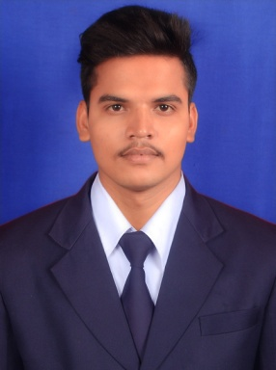
Hapisahoo
Address: ExcisecolonyRathagada
Dhenkanal, Odisha
Pin-759001
E-mail: Hapisahoo58@gmail.com
Mobile: +91-9853533905

Career Objective
To work in the field of practical environment, wherein, I can utilize my knowledge and ability for the development of the sector and also my career in turn.

Key Qualities & PersonalityStrong communication, interpersonal and analytical skills.
- Hardworking.
- Willingness to learn.

Highly organized and dedicated with a positive attitude.
- People-oriented: Enjoy working/being with people.

Educational Qualifications

Capital Engineering College, Bhubaneswar
Graduation, B.Tech in Electrical Engineering, BPUT University, CGPA:-7.33 , April 2016
Orissa institute of engineering & technology, Dhenkanal
Diploma in Electrical Engineering, SCTE&VT, Percentage:- 74.3%, March 2013
B B High School, Dhenkanal
BSE, Percentage:- 35.50%,March 2010

Other Projects
- SOLAR POWER AUTO IRRIGATION SYSTEM
- AUTOMATIC LEAF PLATE MANUFACTURING MACHINE

Other Certifications
- Master Certificate Course in Automation & Process Control (MCCAPC)
Place: Central Tool Room & Training Centre (CTTC)
Chandrasekharpur, Bhubaneswar

Technical Skills
- Electrical Hardware control system
- Pneumatics & Hydraulics Systems
- PLC
- Scada
- TIA Portal
- Auto Cad Electrical
- Electrical Machine
- Robotics

Computer Knowledge
- PGDCA
- Using internet for research
- Programming Language as C, C++.

Hobbies/Interests

Browsing internet.
- Watching inspiration videos and movies.
- Gyming

Personal Details
- Date of birth: 12thJune 1995
- Languages known: English, Hindi, Oriya
Declaration:

I hereby declare that the information furnished above is true to the best of my knowledge and subjected to verification.

Date :- Signature Place:-

